Figure 17.3 illustrates the position of banks as a financial intermediary, with a pattern of deposits flowing into a bank and loans flowing out, and then repayment of the loans flowing back to the bank, with interest payments for the original savers.
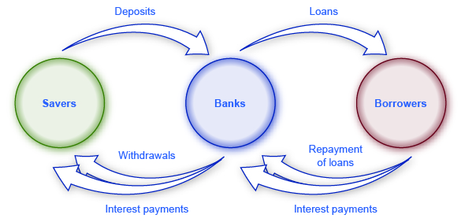
Figure 17.3 Banks as Financial Intermediaries Banks are a financial intermediary because they stand between savers and borrowers. Savers place deposits with banks, and then receive interest payments and withdraw money. Borrowers receive loans from banks, and repay the loans with interest.

Figure 17.4 shows the annual rate of interest paid on a six-month, one-year, and five-year CD since 1984, as reported by Bankrate.com. The interest rates that savings accounts pay are typically a little lower than the CD rate, because financial investors need to receive a slightly higher rate of interest as compensation for promising to leave deposits untouched for a period of time in a CD, and thus forfeiting some liquidity.
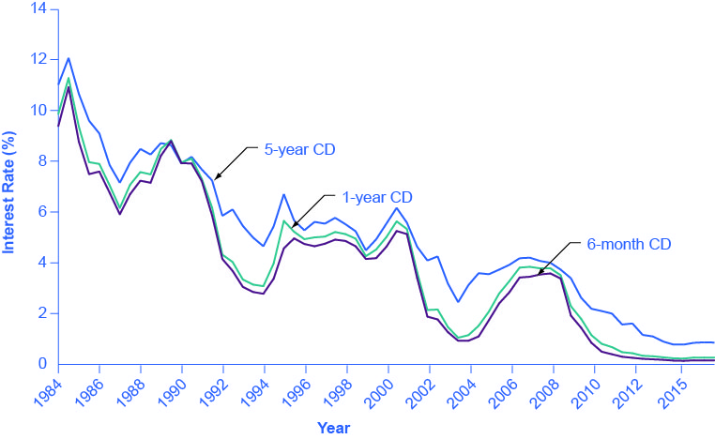
Figure 17.4 Interest Rates on Six-Month, One-Year, and Five-Year Certificates of Deposit The interest rates on certificates of deposit have fluctuated over time. The high interest rates of the early 1980s are indicative of the relatively high inflation rate in the United States at that time. Interest rates fluctuate with the business cycle, typically increasing during expansions and decreasing during a recession. Note the steep decline in CD rates since 2008, the beginning of the Great Recession.

Figure 17.5 shows bond yield for two kinds of bonds: 10-year Treasury bonds (which are officially called “notes”) and corporate bonds issued by firms that have been given an AAA rating as relatively safe borrowers by Moody’s, an independent firm that publishes such ratings. Even though corporate bonds pay a higher interest rate, because firms are riskier borrowers than the federal government, the rates tend to rise and fall together. Treasury bonds typically pay more than bank accounts, and corporate bonds typically pay a higher interest rate than Treasury bonds.
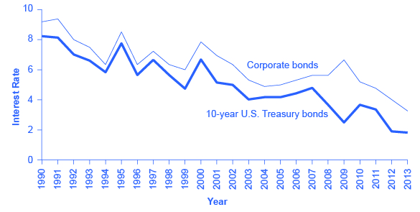
Figure 17.5 Interest Rates for Corporate Bonds and Ten-Year U.S. Treasury Bonds The interest rates for corporate bonds and U.S. Treasury bonds (officially “notes”) rise and fall together, depending on conditions for borrowers and lenders in financial markets for borrowing. The corporate bonds always pay a higher interest rate, to make up for the higher risk they have of defaulting compared with the U.S. government.
The bottom line for bonds: rate of return—low to moderate, depending on the borrower's risk; risk—low to moderate, depending on whether interest rates in the economy change substantially after the bond is issued; liquidity—moderate, because the investor needs to sell the bond before the investor regains the cash.

Other stock market measures focus on where stocks are traded. For example, the New York Stock Exchange monitors the performance of stocks that are traded on that exchange in New York City. The Nasdaq stock market includes about 3,600 stocks, with a concentration of technology stocks. Table 17.1 lists some of the most commonly cited measures of U.S. and international stock markets.
Measure of the Stock Market | Comments
Dow Jones Industrial Average (DJIA): http://indexes.dowjones.com | Based on 30 large companies from a diverse set of representative industries, chosen by analysts at Dow Jones and Company. The index was started in 1896.
Standard & Poor’s 500: http://www.standardandpoors.com | Based on 500 large U.S. firms, chosen by analysts at Standard & Poor’s to represent the economy as a whole.
Wilshire 5000: http://www.wilshire.com | Includes essentially all U.S. companies with stock ownership. Despite the name, this index includes about 7,000 firms.
New York Stock Exchange: http://www.nyse.com | The oldest and largest U.S. stock market, dating back to 1792. It trades stocks for 2,800 companies of all sizes. It is located at 18 Broad St. in New York City.
NASDAQ: http://www.nasdaq.com | Founded in 1971 as an electronic stock market, allowing people to buy or sell from many physical locations. It has about 3,600 companies.
FTSE: http://www.ftse.com | Includes the 100 largest companies on the London Stock Exchange. Pronounced “footsie.” Originally stood for Financial Times Stock Exchange.
Nikkei: http://www.nikkei.co.jp/nikkeiinfo/en/ | Nikkei stands for Nihon Keizai Shimbun, which translates as the Japan Economic Journal, a major business newspaper in Japan. Index includes the 225 largest and most actively traded stocks on the Tokyo Stock Exchange.
DAX: http://www.exchange.de | Tracks 30 of the largest companies on the Frankfurt, Germany, stock exchange. DAX is an abbreviation for Deutscher Aktien Index (German Stock Index).
Table17.1 Some Stock Market Measures

When the Dow Jones average rises from 5,000 to 10,000, you know that the average price of the stocks in that index has roughly doubled. Figure 17.6 shows that stock prices did not rise much in the 1970s, but then started a steady climb in the 1980s. From 2000 to 2013, stock prices bounced up and down, but ended up at about the same level.
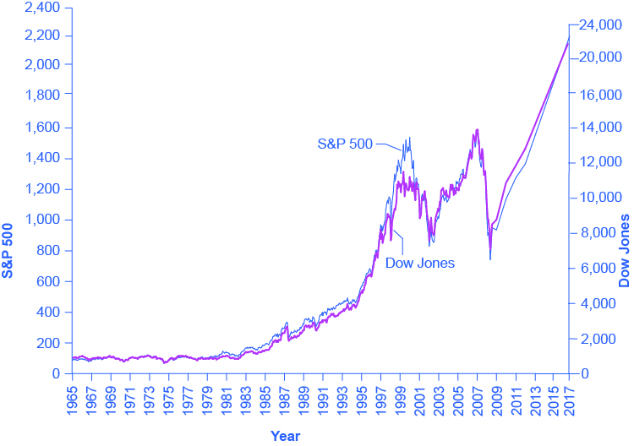
Figure 17.6 The Dow Jones Industrial Index and the Standard & Poor’s 500, 1965–2017 Stock prices rose dramatically from the 1980s up to about 2000. From 2000 to 2013, stock prices bounced up and down, but ended up at about the same level.

Table 17.2 shows the total annual rate of return an investor would have received from buying the stocks in the S&P 500 index over recent decades. The total return here includes both dividends paid by these companies and also capital gains arising from increases in the stock value. (For technical reasons related to how we calculate the numbers, the dividends and capital gains do not add exactly to the total return.) From the 1950s to the 1980s, the average firm paid annual dividends equal to about 4% of its stock value. Since the 1990s, dividends have dropped and now often provide a return closer to 1% to 2%. In the 1960s and 1970s, the gap between percent earned on capital gains and dividends was much closer than it has been since the 1980s. In the 1980s and 1990s, capital gains were far higher than dividends. In the 2000s, dividends remained low and, while stock prices fluctuated, they ended the decade roughly where they had started.
Period | Total Annual Return | Capital Gains | Dividends
1950–1959 | 19.25% | 13.58% | 4.99%
1960–1969 | 7.78% | 4.39% | 3.25%
1970–1979 | 5.88% | 1.60% | 4.20%
1980–1989 | 17.55% | 12.59% | 4.40%
1990–1999 | 18.21% | 15.31% | 2.51%
2000–2009 | −1.00% | −2.70% | 1.70%
2010 | 15.06% | 13.22% | 1.84%
2011 | 2.11% | 0.04% | 2.07%
2012 | 16.00% | 13.87% | 2.13%
Table17.2 Annual Returns on S&P 500 Stocks, 1950–2012
The overall pattern is that stocks as a group have provided a high rate of return over extended periods of time, but this return comes with risks. The market value of individual companies can rise and fall substantially, both over short time periods and over the long run. During extended periods of time like the 1970s or the first decade of the 2000s, the overall stock market return can be quite modest. The stock market can sometimes fall sharply, as it did in 2008.
The bottom line on investing in stocks is that the rate of return over time will be high, but the risks are also high, especially in the short run. Liquidity is also high since one can sell stock in publicly held companies readily for spendable money.

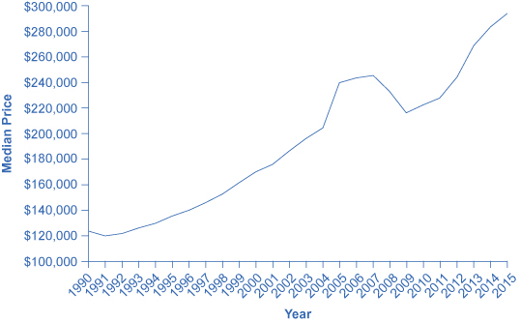
Figure 17.7 The Median Average Sales Price for New Single-Family Homes, 1990–2015 The median price is the price where half of sales prices are higher and half are lower. The median sales price for a new one-family home was $122,900 in 1990. It rose as high as $248,000 in 2007, before falling to $232,000 in 2008. In 2015, the median sales price was $294,000. Of course, this national figure conceals many local differences, like the areas where housing prices are higher or lower, or how housing prices have risen or fallen at certain times. (Source: U.S. Census)

The Tradeoffs between Return and Risk
The discussion of financial investments has emphasized the expected rate of return, the risk, and the liquidity of each investment. Table 17.3 summarizes these characteristics.
Financial Investment | Return | Risk | Liquidity
Checking account | Very low | Very little | Very high
Savings account | Low | Very little | High
Certificate of deposit | Low to medium | Very little | Medium
Stocks | High | Medium to high | Medium
Bonds | Medium | Low to medium | Medium
Mutual funds | Medium to high | Medium to high | Medium to high
Housing | Medium | Medium | Low
Gold | Medium | High | Low
Collectibles | Low to medium | High | Low

Table17.3 Key Characteristics for Financial Investments

WORK IT OUT

Simple and Compound Interest
Simple interest is an interest rate calculation only on the principal amount.
Step 1. Learn the formula for simple interest:
Principal×Rate×Time=Interest
Principal
Step 2. Practice using the simple interest formula.
Example 1: $100 Deposit at a simple interest rate of 5% held for one year is:
$100×0.05×1=$5
$100
Simple interest in this example is $15.
Example 2: $100 Deposit at a simple interest rate of 5% held for three years is:
$100×0.05×3=$15
$100
Simple interest in this example is $5.
Step 3. Calculate the total future amount using this formula:
Total future amount=principal+interest
Total future amount
Step 4. Put the two simple interest formulas together.
Total future amount (with simple interest)=Principal+(Principal×Rate×Time)
Total future amount (with simple interest)
Step 5. Apply the simple interest formula to our three year example.
Total future amount (with simple interest)=$100+($100×0.05×3)=$115
Total future amount (with simple interest)
Compound interest is an interest rate calculation on the principal plus the accumulated interest.
Step 6. To find the compound interest, we determine the difference between the future value and the present value of the principal. This is accomplished as follows:
Future Value=Principal ×
(1 + interest rate)
time
Future Value=Principal × (1 + interest rate)time
Compound interest=Future Value–Present Valve
Compound interest
Step 7. Apply this formula to our three-year scenario. Follow the calculations in
Table 17.4
Year 1
Amount in Bank | $100
Bank Interest Rate | 5%
Total | $105
 | $100 + ($100 × 0.5)
Year 2
Amount in Bank | $105
Bank Interest Rate | 5%
Total | $110.25
 | $105 + ($105 × .05)
Year 3
Amount in Bank | $110.25
Bank Interest Rate | 5%
Total | $115.75
 | $110.25 + ($110.25 × .05)
Compound interest | $115.75 – $100 = $15.75
Table17.4
Step 8. Note that, after three years, the total is $115.76. Therefore the total compound interest is $15.76. This is $0.76 more than we obtained with simple interest. While this may not seem like much, keep in mind that we were only working with $100 and over a relatively short time period. Compound interest can make a huge difference with larger sums of money and over longer periods of time.

